Common Scenario: Student Course Registration System
Database Schema — Relational (PostgreSQL / MySQL)
Create a database named college_db. Use the following tables throughout all exercises.
create table students (
student_id int primary key auto_increment,
first_name varchar(50) not null,
last_name varchar(50) not null,
email varchar(100) unique not null,
date_of_birth date,
department_id int,
enrollment_year int,
foreign key(department_id) references departments(department_id)
);
create table departments(
department_id int primary key auto_increment,
dept_name varchar(100) not null,
hod_name varchar(100),
budget decimal(12,2)
);
create table courses(
course_id int primary key auto_increment,
course_name varchar(150),
course_code varchar(20),
credits int,
department_id int,
foreign key(department_id) references departments(department_id)
);
create table enrollments (
enrollment_id int primary key auto_increment,
student_id int,
foreign key(student_id) references students(student_id),
course_id int,
foreign key(course_id) references courses(course_id),
enrollment_date date,
grade char(2)
);

create table professors(
professor_id int primary key auto_increment,
prof_name varchar(100) not null,
email varchar(100) unique,
department_id int,
foreign key(department_id) references departments(department_id),
salary decimal(10,2)
)
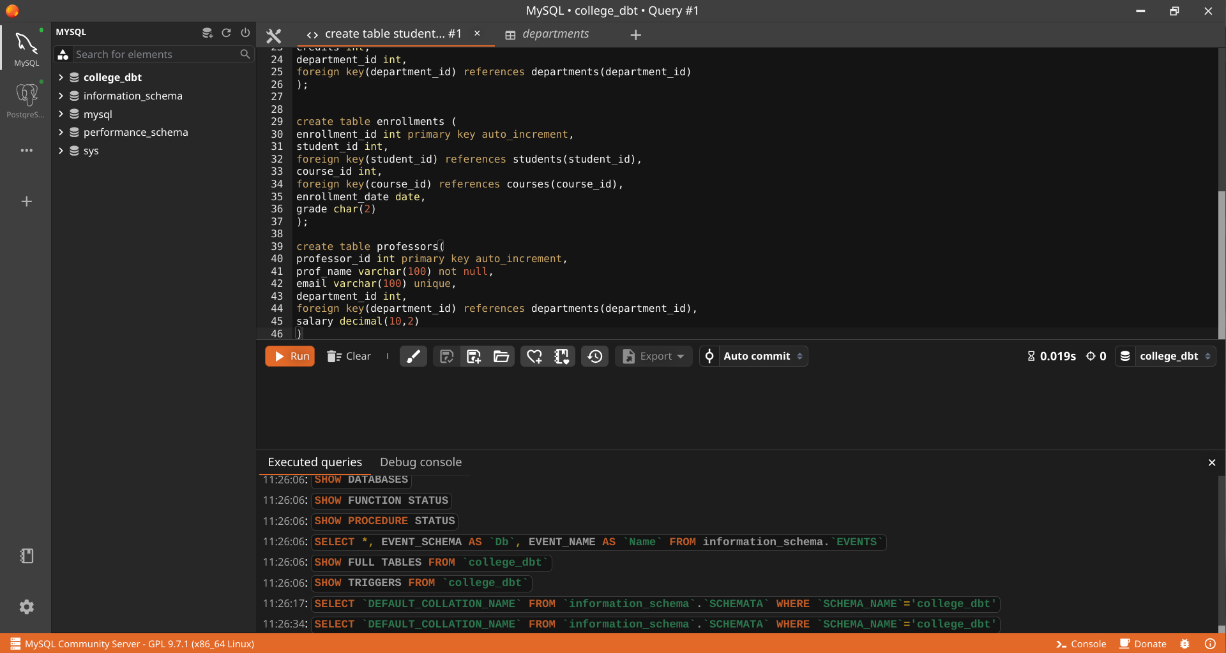
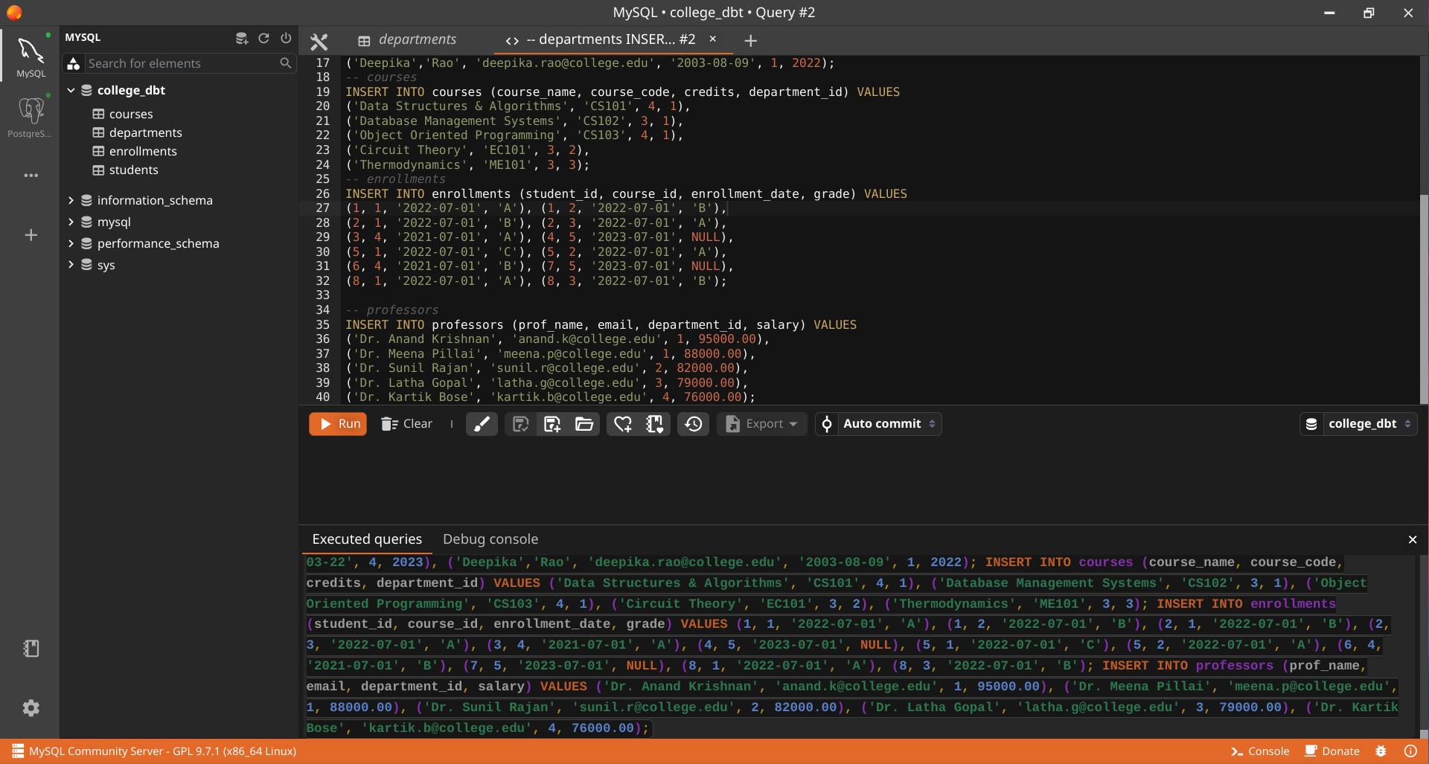





HANDS-ON 1
Schema Design & Core SQL — DDL and Normalisation
Task 1: Create the Database and Tables





Task 2: Verify Normalisation
1NF:-
-> It doesn’t needs a ordered data i.e every column needs to have one atomic value
-> Every table needs to have primary key
-> Repeating or the duplication is not allowed
-> Mixing data types in the same column is not allowed
If the multiple phone number is stored in one filed it would violate the 1NF rules of every column having atomic values.
All the tables satisfy the 1NF Rules

2NF:-
-> The tables must satisfy the 1NF condition
-> Every non key attributes must depend on the primary key column
-> Partial Dependency is not allowed
In the enrollment table enrollment_date and grade depend on the enrollment of a student in a course. They do not depend only on student_id or only on course_id so enrollment table satisfies 2NF

3NF:-
-> It must satisfy 2NF condition
-> There should be no dependency between non key attributes
-> Non key attributes should only depend only on primary key

